Reverse Shell Walkthrough

Requirements:

Nmap

Netcat

Difficulty:

Easy

Walkthrough:

1. Build and host the docker server.
   * docker build -t <NAME> .
   * docker run -p 80:80 <NAME>
2. Run NMAP to find the open port.

1. Navigating to the webpage on port 80 reveals a PHP web shell.

1. The web shell can be used to open a reverse shell.



The reverse shell one-liner can be found: <https://github.com/swisskyrepo/PayloadsAllTheThings/blob/master/Methodology%20and%20Resources/Reverse%20Shell%20Cheatsheet.md#php>

The reverse shell is caught using Netcat.

1. The config file found within the website directory reveals a set of credentials.

1. Using the found credentials to switch users.

1. Within the user’s home directory there is a script that has SUID permissions and is executable by the user.

1. Following the instructions and entering “Ctrl+C” when the program is executing exits the reverse shell.

1. To be able to enter “Ctrl+C” without exiting the reverse shell requires upgrading the shell to be fully interactive. The following series of commands can be used to elevate the shell.
   * python3 -c 'import pty; pty.spawn("/bin/bash")'
   * CTRL + Z
   * stty raw -echo; fg
   * export TERM=xterm-256color

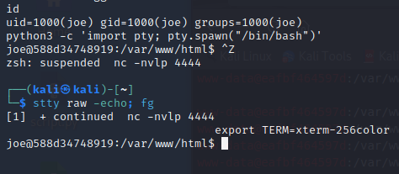

1. The fully interactive shell allows the script to detect the “Ctrl+C” and output the flag.

